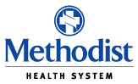

Methodist Health System
Nursing Scholarship Application
2025 – 2026

(Return by June 16th, 2025)

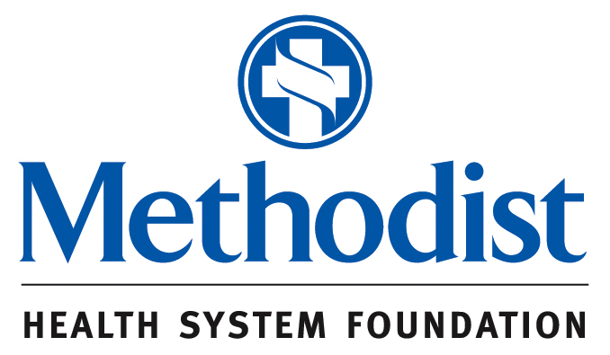

NURSING SCHOLARSHIP APPLICATION
Scholarship Awarded by Methodist Health System Foundation

Please Check: □ Initial Application □ Renewal

Date of Application: _________

PERSONAL INFORMATION

Name of Applicant: _________________________________________________________
First MI Last

Address: _________________________________________________________________

________________________________________________________________________
City State Zip Code

Phone: ( ) __________________________________

E-Mail address _________________________________

Please list names and relationships of any immediate family members that are employed by Methodist Health System: ____________________________________________________
_________________________________________________________________________

EMPLOYMENT INFORMATION

Present Employer: __________________________________________________________

If you are a Methodist employee please provide your employee number: __________________

Dates Employed: _________________________________________________________

Business Phone: ( ) ______________

Job Title___________________________ Current Salary $___________

For new applicants, this application must be accompanied by two nursing scholarship Academic Evaluations from current or former college instructors, evidence of acceptance/enrollment and a transcript substantiating current grade point average. For renewal applications, the past awardee needs only to submit evidence of continuing enrollment and a current grade transcript along with a completed application form. A current grade point average of 3.0 must be maintained to be considered for continuing scholarship support.
OTHER INFORMATION

Nursing School you are/will attend__________________________

Next semester for which you will be enrolled__________________

Contact to verify enrollment_______________________________

Program: □ LVN to RN □ ADN □ RN to BSN □ BSN □ MSN □ PhD

Do you plan to seek employment at Methodist when you graduate? _____________________

Please write a brief statement on your reason(s) for wanting to become a nurse or further your education.

Please describe any funding currently being received for nursing education expenses:

In considering scholarship applications, Methodist Health System will not discriminate on the basis of race, color, religion, national origin, age, sex, sexual orientation, gender expression, disability, marital status, or ancestry. Applications received without all of the required information will not be considered. Please note that this scholarship may affect any tuition assistance you may be eligible for through Human Resources. Additionally, this scholarship award covers tuition, fees and books. The scholarship award will be paid for the Fall and Spring semesters only. Application deadline is June 16, 2025.

Please direct completed application to:

Methodist Health System – Human Resources
Nursing Scholarship
1441 N. Beckley Ave.
Dallas, TX 75203
(214) 947-6505
MDMCHRTeam@mhd.com

I agree to abide by all rules and regulations as specified for the Methodist Health System (MHS) Nursing Scholarship Program. I am aware of the requirements as specified by the Nursing Scholarship Committee. I agree to supply the Nursing Scholarship Committee with any requested information. I further agree to return any scholarship support received for class work in which I did not subsequently enroll or complete the respective courses. Finally, I agree to present the scholarship committee with any documentation regarding any additional sources of funding received after the scholarship decision is determined. I recognize that failure to provide this information will result in the loss of my award.

Applicant Signature _____________________________________ ____________________
Signature Date

General Information and Timeline

All applications and other materials must be received in the Human Resources office by the deadline of June 16, 2025. Payment will be made directly to the scholarship recipient.

Scholarships are available for all levels of professional nursing education. Applicants should note that awards are made annually by the scholarship committee based on the availability of funds and that this funding may impact the applicant’s tuition reimbursement from MHS. Applicants are required to disclose all funding sources and funds may only be applied to tuition, fees and books.

Step 1:

To be considered for the nursing scholarship for the academic year of Fall 2025-Spring 2026, applicants must:

- Complete the application procedure and provide all requested information by mail or email by June 1, including:

- Application form
- Proof of enrollment or acceptance in an accredited nursing program
- Transcripts / Grade Reports
- Additional information including references as requested

- Provide current contact information and update information as needed

- Be currently enrolled or show proof of acceptance in an approved nursing school

- Provide proof of successful completion of classes with a minimum of a 3.0 average

- Provide 2 Nursing Scholarship Academic Evaluations from current or former college instructors

Step 2:

Following the selection committee meeting, awardees will be notified by letter during the month of August. Checks for the Fall semester will be mailed in September (current Methodist Health System employees will receive their award as part of their paycheck). Failure to maintain current contact information will significantly delay this process.

METHODIST HEALTH SYSTEM
Nursing Scholarship Academic Evaluation

I, _____________________________ waive my right/do not wave my right to view this evaluation.
(Circle one)

_________________________________ _____/_____/________
(Applicant name) (Date)

Dear Instructor/Professor:

_______________________ is applying for a nursing scholarship through Methodist Heath System and your evaluation would greatly assist us in the decision making process. Please respond to the statements and questions below.

Length of time acquainted with this candidate: ___< 1 year ___1 year ___2 years ___3 years ___>3 years

Nature of relationship: Student in your class ______ Other____________________________

Please rate the candidate using a reference group of his/her peers. Mark an X in the appropriate space.
Category Top 25% Middle 50% Bottom 25%
Attendance
Punctuality
Participation
Quality of Written Work
Ability to Express Ideas
Ability to Work in a Group
Leadership Skills
Performance on Exams
Overall Ability

Strengths/Assets of this candidate__________________________________________________________
______________________________________________________________________________________
______________________________________________________________________________________

Recommendation: _____Highly Recommend
_____Recommend
_____Marginally Recommend
_____Do Not Recommend

Is there any other information you feel would be important to consider? ___Yes ___No

If yes, ___________________________________________________________________________________

_____________________ ______________________ ______________ ___________________ Printed Name: Signature: Date: Phone Number:

Please return to: Nursing Scholarships, MHS Human Resources,
1441 North Beckley Avenue, Dallas, Texas 75203
MDMCHRTeam@mhd.com

